Optimizing CareBridgeDB with Relationships, Loading Strategies, and Performance Tuning Using EF Core
DAY 5

Building High-Performance Data Access Layers with EF Core
HCA Healthcare India · Enterprise .NET & C# Developer Track

Session Overview
Day 4 established the fundamentals: ORM concepts, database-first scaffolding, the DbContext, basic CRUD, and basic LINQ against CareBridgeDB. This day assumes all of that and goes deeper into the topics that separate a working prototype from a production-grade data layer: how EF Core models relationships, how it tracks changes, and - the core of the day - how it loads related data efficiently.
The entire session runs against the existing CareBridgeDB database. No new database is created. The schema - Department, Provider, Patient, Insurance, Encounter, Diagnosis, Procedure, Claim - and its foreign keys are the source of truth for every example.

# | Module | Outcome
1 | Relationships & navigation properties | Model the CareBridge graph accurately in C#
2 | Change tracking deep dive | Understand entity states and when tracking helps or hurts
3 | Loading strategies (major focus) | Choose eager / lazy / explicit deliberately, with evidence
4 | Advanced LINQ with EF Core | Filter, project, sort, group, aggregate, join on real data
5 | Tracking vs NoTracking | Make read-heavy reporting fast and light
6 | Query optimization & performance | Diagnose and fix slow queries; avoid common traps
7 | Hands-on labs (3 levels) | Apply everything independently on CareBridgeDB

Business Case Study

Organization background
CareBridge Health Network is a multi-facility hospital group running on the CareBridgeDB database the class built and populated earlier in the week. The database holds roughly 1000 patients, 2246 encounters, over 3000 diagnoses, and 2246 claims across departments such as Cardiology, Emergency, and Oncology, with providers, insurance payers, and billing all linked by foreign keys.

Current challenges
- Clinical and billing screens each query single tables and stitch related data manually, producing slow pages and duplicated logic.
- Reporting dashboards pull thousands of rows and feel sluggish, because every read is fully change-tracked even though nothing is edited.
- Of 2246 claims, 434 are Denied and 606 are Submitted (unpaid) - a large revenue backlog that no current screen surfaces clearly.

Why EF Core is being used
EF Core lets the team work with the hospital's data as connected C# objects - a patient with their encounters, diagnoses, and claims - while keeping SQL Server as the system of record. The goal of Day 5 is to use EF Core's relationship and loading features to make these screens both correct and fast.

Expected business outcomes
Outcome | How EF Core Day-5 skills deliver it
Faster patient and billing screens | Eager loading fetches a full record in one round-trip
Lower server memory on dashboards | NoTracking on read-only reporting queries
Fewer database queries under load | Avoiding the N+1 problem from careless lazy loading
Visible revenue backlog | Aggregation queries over the real Claim statuses

Problem Statement

STEP 1 - VERIFY CURRENT ROW COUNTS

SELECT COUNT(*) AS Patients
FROM Patient;

SELECT COUNT(*) AS Encounters
FROM Encounter;

SELECT COUNT(*) AS Diagnoses
FROM Diagnosis;

SELECT COUNT(*) AS Claims
FROM Claim;

STEP 2 - CREATE A PERFORMANCE TEST PATIENT

INSERT INTO Patient
(
Mrn,
FullName,
DateOfBirth,
Gender,
City,
IsActive
)
VALUES
(
'MRN999999',
'Rahul Verma',
'1985-06-15',
'M',
'Hyderabad',
1
);

STEP 3 - VERIFY PATIENT ID

SELECT *
FROM Patient
WHERE Mrn = 'MRN999999';

Note the PatientId generated.

For the scripts below we assume:

PatientId = 1003

If your PatientId is different,
replace 1003 everywhere.

STEP 4 - CREATE 500 ENCOUNTERS

INSERT INTO Encounter
(
PatientId,
ProviderId,
DepartmentId,
AdmitDate,
DischargeDate,
EncounterType
)
SELECT
1003,
1,
1,
DATEADD(DAY,-v.number,GETDATE()),
GETDATE(),
'Outpatient'
FROM master..spt_values v
WHERE v.type = 'P'
AND v.number < 500;

STEP 5 - VERIFY ENCOUNTERS

SELECT COUNT(*) AS EncounterCount
FROM Encounter
WHERE PatientId = 1003;

Expected: 500+

STEP 6 - CREATE DIAGNOSES

INSERT INTO Diagnosis
(
EncounterId,
IcdCode,
Description,
DiagnosedOn
)
SELECT
EncounterId,
'I10',
'Hypertension',
GETDATE()
FROM Encounter
WHERE PatientId = 1003;

STEP 7 - VERIFY DIAGNOSES

SELECT COUNT(*) AS DiagnosisCount
FROM Diagnosis d
INNER JOIN Encounter e
ON d.EncounterId = e.EncounterId
WHERE e.PatientId = 1003;

Expected: 500+

STEP 8 - CREATE CLAIMS

INSERT INTO Claim
(
EncounterId,
InsuranceId,
BilledAmount,
ReimbursedAmt,
Status
)
SELECT
EncounterId,
1,
15000,
12000,
'Paid'
FROM Encounter
WHERE PatientId = 1003;

STEP 9 - VERIFY CLAIMS

SELECT COUNT(*) AS ClaimCount
FROM Claim c
INNER JOIN Encounter e
ON c.EncounterId = e.EncounterId
WHERE e.PatientId = 1003;

Expected: 500+

STEP 10 - CREATE EVEN MORE DATA

Run this only if you want a more data in demo.

Creates roughly 20,000 additional encounters.

INSERT INTO Encounter
(
PatientId,
ProviderId,
DepartmentId,
AdmitDate,
DischargeDate,
EncounterType
)
SELECT
p.PatientId,
1,
1,
DATEADD(DAY,-ABS(CHECKSUM(NEWID())) % 365,GETDATE()),
GETDATE(),
'Outpatient'
FROM Patient p
CROSS JOIN
(
SELECT TOP 20
ROW_NUMBER() OVER(ORDER BY (SELECT NULL)) AS N
FROM sys.objects
) x;

STEP 11 - CREATE DIAGNOSES FOR NEW ENCOUNTERS

INSERT INTO Diagnosis
(
EncounterId,
IcdCode,
Description,
DiagnosedOn
)
SELECT
EncounterId,
'I10',
'Hypertension',
GETDATE()
FROM Encounter
WHERE EncounterId NOT IN
(
SELECT DISTINCT EncounterId
FROM Diagnosis
);

STEP 12 - CREATE CLAIMS FOR NEW ENCOUNTERS

INSERT INTO Claim
(
EncounterId,
InsuranceId,
BilledAmount,
ReimbursedAmt,
Status
)
SELECT
EncounterId,
1,
15000,
12000,
'Paid'
FROM Encounter
WHERE EncounterId NOT IN
(
SELECT DISTINCT EncounterId
FROM Claim
);

FINAL VERIFICATION

SELECT COUNT(*) AS Patients
FROM Patient;

SELECT COUNT(*) AS Encounters
FROM Encounter;

SELECT COUNT(*) AS Diagnoses
FROM Diagnosis;

SELECT COUNT(*) AS Claims
FROM Claim;

Expected Approximate Results

Patients : 1000+
Encounters : 22000+
Diagnoses : 22000+
Claims : 22000+

RELATIONSHIP NAVIGATION WITH EF CORE

Yesterday we learned how EF Core performs CRUD operations and how LINQ allows us to query SQL Server using C#.

However, enterprise applications rarely work with a single table.
- A Patient belongs to many Encounters.
- An Encounter can contain multiple Diagnoses.
- An Encounter can generate multiple Claims.
- An Insurance company can be associated with many Claims.

In a real healthcare application, developers spend far more time navigating relationships than performing simple CRUD operations.

If relationships are not modeled correctly, developers end up writing manual joins, multiple queries, and repetitive code.

Understanding relationships is the foundation for everything else we learn today.

Business Problem
CareBridge Hospital is building a new Patient 360 Dashboard.
When a clinician opens a patient record, they expect to see:
- Patient Information
- Encounter History
- Diagnoses
- Claims
- Insurance Information
all in a single view.

The current development team is manually querying every table separately. This approach works but quickly becomes difficult to maintain as the application grows.

The goal of this module is to learn how EF Core relationships allow developers to navigate related data naturally using C# objects.

Expected Business Outcome
Instead of writing multiple queries and joins manually, developers can move naturally between related objects. The code becomes shorter, easier to maintain, and easier to understand.

STEP 1 - CREATE PROJECT
Open Visual Studio 2022.
Click: Create a New Project
Select: Console App
Click Next.
Project Name: CareBridge.PerformanceLab
Framework: .NET 8
Click Create.

STEP 2 - INSTALL EF CORE PACKAGES
Open:
Tools
→ NuGet Package Manager
→ Package Manager Console
Run:
Install-Package Microsoft.EntityFrameworkCore.SqlServer
Install-Package Microsoft.EntityFrameworkCore.Tools
Install-Package Microsoft.EntityFrameworkCore.Design
Wait until all packages install successfully.

STEP 3 - SCAFFOLD THE DATABASE
Open Package Manager Console.
Run:
Scaffold-DbContext "Server=localhost;Database=CareBridgeDB;Trusted_Connection=True;TrustServerCertificate=True" Microsoft.EntityFrameworkCore.SqlServer -OutputDir Models -Context CareBridgeContext -Force

Expected Result
Visual Studio creates:
Models
Patient.cs
Encounter.cs
Diagnosis.cs
Claim.cs
Insurance.cs
Provider.cs
Department.cs
and
CareBridgeContext.cs

STEP 4 - OBSERVE RELATIONSHIPS

Open Patient.cs
We will notice something new. EF Core generated navigation properties.
Example:
public virtual ICollection Encounters { get; set; }
Explanation:
One patient can have many encounters.
EF Core discovered this automatically from the foreign key relationship.

Open Encounter.cs
We will see:
public virtual Patient Patient { get; set; }
This means:
Many Encounters belong to one Patient.

STEP 5 – CREATE MAIN MENU
COMPLETE PROGRAM.CS

using CareBridge.PerformanceLab.Models1;
using var db = new CareBridgeContext();
while (true)
{
Console.Clear();
Console.WriteLine("=================================");
Console.WriteLine(" CAREBRIDGE PERFORMANCE LAB");
Console.WriteLine("=================================");
Console.WriteLine("1. View Patient");
Console.WriteLine("2. View Patient Encounters");
Console.WriteLine("3. Exit");
Console.WriteLine();

Console.Write("Choose Option: ");

string? choice = Console.ReadLine();

switch (choice)
{
case "1":
ShowPatient();
break;

case "2":
ShowEncounters();
break;

case "3":
return;

default:
Console.WriteLine("Invalid Option");
break;
}

Console.WriteLine();
Console.WriteLine("Press any key to continue...");
Console.ReadKey();
}
static void ShowPatient()
{
using var db = new CareBridgeContext();
var patient =
db.Patients
.FirstOrDefault(p => p.Mrn == "MRN999999");

if (patient == null)
{
Console.WriteLine("Patient not found.");
return;
}

Console.WriteLine();
Console.WriteLine("PATIENT DETAILS");
Console.WriteLine("----------------------------");

Console.WriteLine($"Patient Id : {patient.PatientId}");
Console.WriteLine($"MRN : {patient.Mrn}");
Console.WriteLine($"Name : {patient.FullName}");
Console.WriteLine($"City : {patient.City}");
Console.WriteLine($"Active : {patient.IsActive}");
}
static void ShowEncounters()
{
using var db = new CareBridgeContext();
var patient =
db.Patients
.FirstOrDefault(p => p.Mrn == "MRN999999");

if (patient == null)
{
Console.WriteLine("Patient not found.");
return;
}

var encounters =
db.Encounters
.Where(e => e.PatientId == patient.PatientId)
.ToList();

Console.WriteLine();
Console.WriteLine("PATIENT ENCOUNTERS");
Console.WriteLine("----------------------------");

Console.WriteLine($"Patient Name : {patient.FullName}");
Console.WriteLine($"Encounter Count : {encounters.Count}");
}

MEASURABLE OUTCOME
Students can now see that a single patient may have hundreds of related records.
Patient: 1
Encounters: 500+
Diagnoses: 500+
Claims: 500+
This sets up the business problem for the next module.
Question:
How do we efficiently load all this related information?
That is exactly what Module 2 (Lazy Loading and the N+1 Query Problem) will solve.

MODULE 2 - THE N+1 QUERY PROBLEM

Why This Matters
In Module 1, we learned how EF Core relationships connect Patients and Encounters.
The application worked correctly.
The SQL Profiler showed only two queries:
- Get Patient
- Get Encounters
Everything looked fine.

Unfortunately, real healthcare screens rarely stop there.
A clinician opening the Patient 360 Dashboard does not only want Encounters.
They also want:
- Diagnoses
- Claims
- Insurance Information
- Procedures

The most common mistake developers make is loading this data one record at a time inside a loop.
The application still works. The results are correct.But performance collapses.

This problem is known as the N+1 Query Problem and is one of the most common performance issues in enterprise applications.

Business Problem
CareBridge Hospital launches the new Patient 360 Dashboard.
Rahul Verma now has:
- 500 Encounters
- 500+ Diagnoses
- 500+ Claims

The development team decides to load claims for each encounter individually.
The code looks reasonable. However, every encounter triggers another database query.
The result is hundreds of SQL calls for a single patient screen.

Users begin reporting:
"Patient records are taking forever to load."
Management wants to know why.
Today's objective is to discover the problem before learning how to fix it.

Expected Business Outcome
We will understand:
- Why applications become slow
- What the N+1 Query Problem is
- How to identify it using SQL Profiler
- Why loading strategies matter

STEP 1 - OPEN SQL PROFILER
Before running the application:
Open SQL Server Profiler.
File
→ New Trace
Connect to SQL Server.
Go to: Events Selection
Uncheck everything.
Enable only:
TSQL
✓ SQL:BatchStarting
✓ SQL:BatchCompleted
Stored Procedures
✓ RPC:Completed
Click Run.
Keep Profiler running during the lab.

Program.cs (revised)

using System.Diagnostics;
using CareBridge.PerformanceLab.Models;
while (true)
{
Console.Clear();
Console.WriteLine("=================================");
Console.WriteLine(" CAREBRIDGE PERFORMANCE LAB");
Console.WriteLine("=================================");
Console.WriteLine();

Console.WriteLine("1. View Patient");
Console.WriteLine("2. View Patient Encounters");
Console.WriteLine("3. Simulate N+1 Problem");
Console.WriteLine("4. Exit");

Console.WriteLine();

Console.Write("Choose Option: ");

string? choice = Console.ReadLine();

switch (choice)
{
case "1":
ShowPatient();
break;

case "2":
ShowEncounters();
break;

case "3":
SimulateNPlusOne();
break;

case "4":
return;

default:
Console.WriteLine("Invalid Option");
break;
}

Console.WriteLine();
Console.WriteLine("Press any key to continue...");
Console.ReadKey();
}
static void ShowPatient()
{
using var db = new CareBridgeContext();
var patient =
db.Patients
.FirstOrDefault(p => p.Mrn == "MRN999999");

if (patient == null)
{
Console.WriteLine("Patient not found.");
return;
}

Console.WriteLine();
Console.WriteLine("PATIENT DETAILS");
Console.WriteLine("----------------------------");

Console.WriteLine($"Patient Id : {patient.PatientId}");
Console.WriteLine($"MRN : {patient.Mrn}");
Console.WriteLine($"Name : {patient.FullName}");
Console.WriteLine($"City : {patient.City}");
Console.WriteLine($"Active : {patient.IsActive}");
}
static void ShowEncounters()
{
using var db = new CareBridgeContext();
var patient =
db.Patients
.FirstOrDefault(p => p.Mrn == "MRN999999");

if (patient == null)
{
Console.WriteLine("Patient not found.");
return;
}

var encounters =
db.Encounters
.Where(e => e.PatientId == patient.PatientId)
.ToList();

Console.WriteLine();
Console.WriteLine("PATIENT ENCOUNTERS");
Console.WriteLine("----------------------------");

Console.WriteLine($"Patient Name : {patient.FullName}");
Console.WriteLine($"Encounter Count : {encounters.Count}");

Console.WriteLine();
Console.WriteLine("Recent Encounters");
Console.WriteLine("----------------------------");

foreach (var encounter in encounters.Take(10))
{
Console.WriteLine(
$"{encounter.EncounterId} | {encounter.EncounterType} | {encounter.AdmitDate:d}");
}
}
static void SimulateNPlusOne()
{
using var db = new CareBridgeContext();
Console.WriteLine();
Console.WriteLine("SIMULATING N+1 QUERY PROBLEM");
Console.WriteLine("----------------------------");

var patient =
db.Patients
.FirstOrDefault(p => p.Mrn == "MRN999999");

if (patient == null)
{
Console.WriteLine("Patient not found.");
return;
}

Stopwatch stopwatch = Stopwatch.StartNew();

var encounters =
db.Encounters
.Where(e => e.PatientId == patient.PatientId)
.ToList();

Console.WriteLine();
Console.WriteLine($"Patient Name : {patient.FullName}");
Console.WriteLine($"Encounters Loaded : {encounters.Count}");

int totalClaims = 0;

foreach (var encounter in encounters)
{
var claims =
db.Claims
.Where(c =>
c.EncounterId ==
encounter.EncounterId)
.ToList();

totalClaims += claims.Count;
}

stopwatch.Stop();

Console.WriteLine();
Console.WriteLine($"Total Claims Loaded : {totalClaims}");

Console.WriteLine();
Console.WriteLine("PERFORMANCE SUMMARY");
Console.WriteLine("----------------------------");

Console.WriteLine("Patient Queries : 1");
Console.WriteLine("Encounter Queries : 1");
Console.WriteLine($"Claim Queries : {encounters.Count}");

Console.WriteLine();

Console.WriteLine(
$"Approx Total Queries : {encounters.Count + 2}");

Console.WriteLine(
$"Elapsed Time : {stopwatch.ElapsedMilliseconds} ms");

Console.WriteLine();
Console.WriteLine("Check SQL Profiler Now");
Console.WriteLine("----------------------------");
Console.WriteLine("Notice how the Claim query executes repeatedly.");
Console.WriteLine("One query is executed for every encounter.");
}

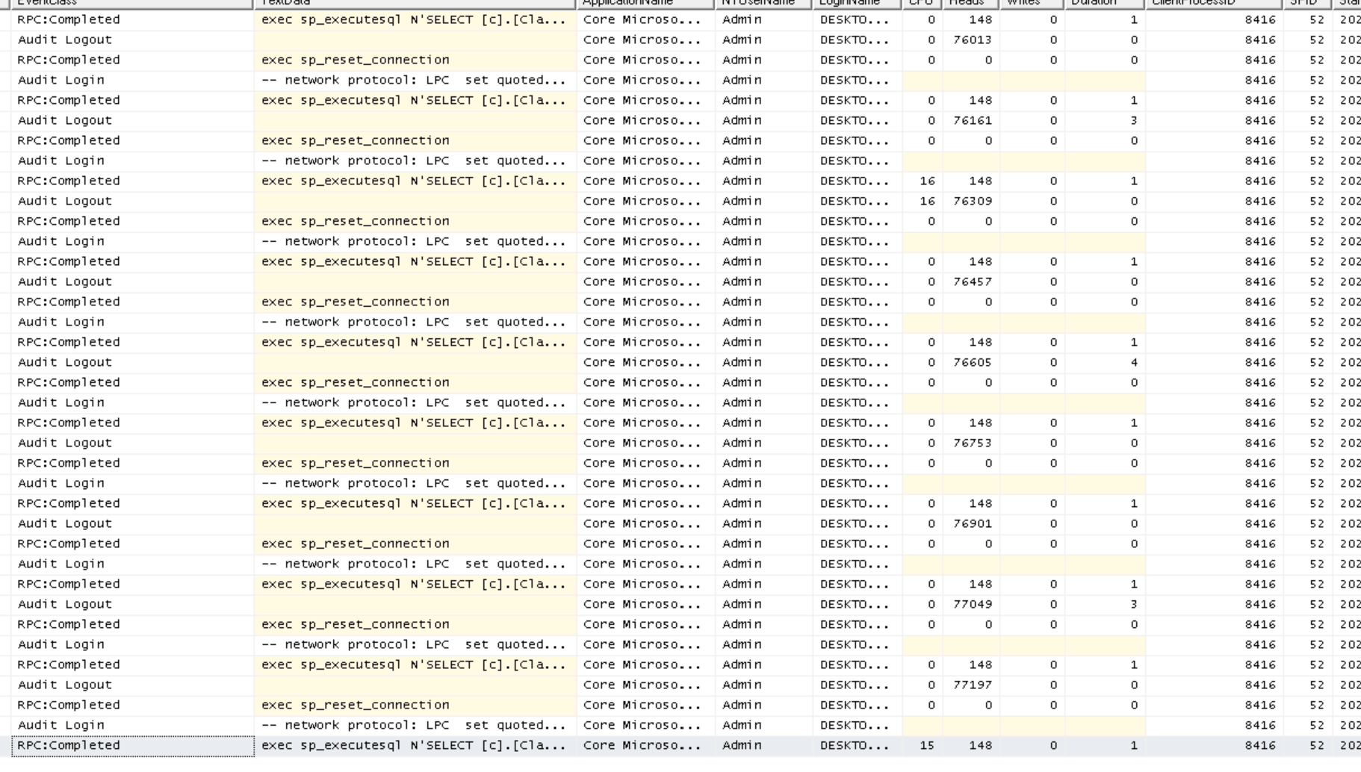

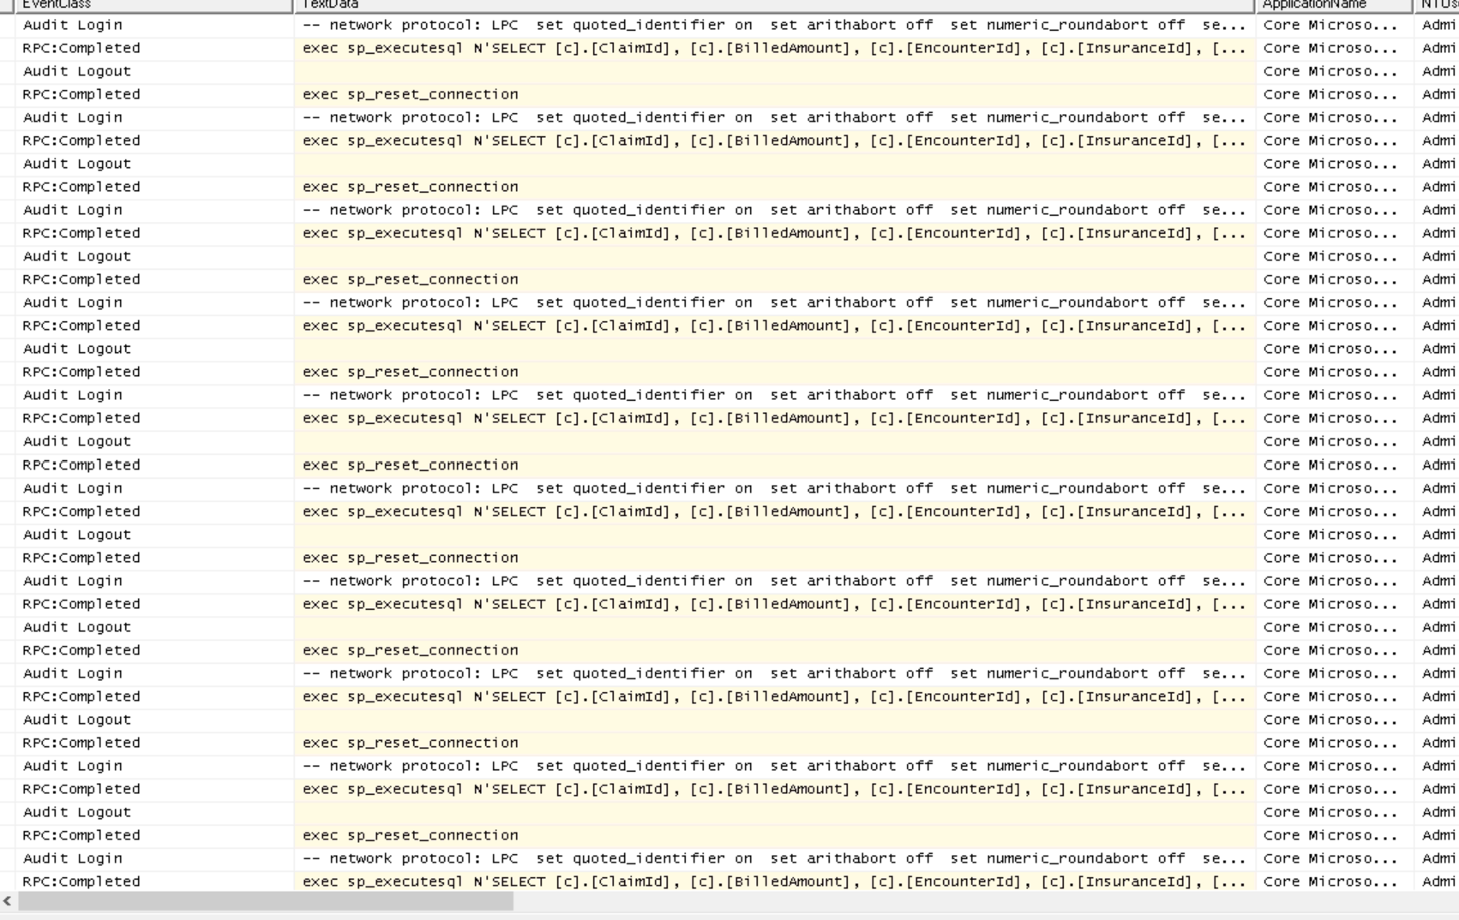

STEP 7 - OBSERVE SQL PROFILER
This is the most important step.
We should now switch to SQL Profiler.
They will see:
SELECT Patient ...
SELECT Encounter ...
SELECT Claim ...
SELECT Claim ...
SELECT Claim ...
SELECT Claim ...
SELECT Claim ...
SELECT Claim ...
hundreds of times.
Every encounter generated another SQL query.

The N+1 Query Problem gets its name because the application executes one query to load the parent records (Encounters) and then executes an additional query for each individual encounter to load related data such as Claims.

For example, if a patient has 10 encounters, the application executes 1 query to retrieve the encounters and then 10 more queries to retrieve claims, resulting in 11 total queries.

If the patient has 100 encounters, the application executes 101 queries. In our CareBridge scenario, Rahul Verma has 500 encounters, which means the application executes 1 query to load the encounters and 500 additional queries to load claims, resulting in approximately 501 queries.

As the patient's medical history grows, the number of database round-trips increases dramatically, causing slower page loads, higher database workload, and a poor user experience.

This is why the N+1 Query Problem is considered one of the most common performance issues in enterprise applications.

REAL BUSINESS IMPACT
A nurse opens a patient record.
Instead of: 1 optimized query
the application executes:500+ database calls.

The database server becomes busy.
Network traffic increases.
Users wait longer.
Doctors complain.
Management sees performance degradation.

Nothing is wrong with SQL Server. Nothing is wrong with the hardware. The problem is the application design.

MODULE 3 - EAGER LOADING WITH INCLUDE()

Why This Matters
In Module 2, we discovered one of the most common performance problems in enterprise applications: the N+1 Query Problem.

The application worked correctly and returned the expected results. However, it loaded claims separately for every encounter. Since Rahul Verma has approximately 500 encounters, the application generated over 500 database calls to retrieve claims.

SQL Server was forced to repeatedly execute nearly identical queries, increasing database workload and slowing down the Patient 360 screen.

The problem was not SQL Server. The problem was not hardware. The problem was the way the application fetched data.

EF Core provides a solution called Eager Loading. Instead of loading related data one record at a time, Eager Loading retrieves the entire object graph in a single query.

This allows EF Core to bring back the Patient, Encounters, and Claims together, dramatically reducing database round-trips.

Business Problem
The Patient 360 Dashboard still takes several seconds to load because the application is making hundreds of SQL calls.
Management wants:
- Faster patient lookup
- Less database traffic
- Better user experience
- No database redesign
- No hardware upgrades

The development team decides to replace the N+1 implementation with Eager Loading.
Expected Business Outcome

Instead of executing more than 500 SQL queries, the application should execute a single optimized query.
The Patient 360 screen should load significantly faster.

We will verify the improvement using:
- SQL Profiler
- Stopwatch timing
- Query counts

STEP 1 - CLEAR SQL PROFILER
Before running this module:
Stop the existing trace.
File
→ New Trace
Enable only:
TSQL
✓ SQL:BatchStarting
✓ SQL:BatchCompleted
Stored Procedures
✓ RPC:Completed
Click Run.
The Profiler window should now be empty.

Program.cs (revised)

using System.Diagnostics;
using Microsoft.EntityFrameworkCore;
using CareBridge.PerformanceLab.Models;
while (true)
{
Console.Clear();
Console.WriteLine("=================================");
Console.WriteLine(" CAREBRIDGE PERFORMANCE LAB");
Console.WriteLine("=================================");
Console.WriteLine();

Console.WriteLine("1. View Patient");
Console.WriteLine("2. View Patient Encounters");
Console.WriteLine("3. Simulate N+1 Problem");
Console.WriteLine("4. Eager Loading Demo");
Console.WriteLine("5. Exit");

Console.WriteLine();
Console.Write("Choose Option: ");

string? choice = Console.ReadLine();

switch (choice)
{
case "1":
ShowPatient();
break;

case "2":
ShowEncounters();
break;

case "3":
SimulateNPlusOne();
break;

case "4":
EagerLoadingDemo();
break;

case "5":
return;

default:
Console.WriteLine("Invalid Option");
break;
}

Console.WriteLine();
Console.WriteLine("Press any key to continue...");
Console.ReadKey();
}
static void ShowPatient()
{
using var db = new CareBridgeContext();
var patient =
db.Patients
.FirstOrDefault(p => p.Mrn == "MRN999999");

if (patient == null)
{
Console.WriteLine("Patient not found.");
return;
}

Console.WriteLine();
Console.WriteLine("PATIENT DETAILS");
Console.WriteLine("----------------------------");

Console.WriteLine($"Patient Id : {patient.PatientId}");
Console.WriteLine($"MRN : {patient.Mrn}");
Console.WriteLine($"Name : {patient.FullName}");
Console.WriteLine($"City : {patient.City}");
Console.WriteLine($"Active : {patient.IsActive}");
}
static void ShowEncounters()
{
using var db = new CareBridgeContext();
var patient =
db.Patients
.FirstOrDefault(p => p.Mrn == "MRN999999");

if (patient == null)
{
Console.WriteLine("Patient not found.");
return;
}

var encounters =
db.Encounters
.Where(e => e.PatientId == patient.PatientId)
.ToList();

Console.WriteLine();
Console.WriteLine("PATIENT ENCOUNTERS");
Console.WriteLine("----------------------------");

Console.WriteLine($"Patient Name : {patient.FullName}");
Console.WriteLine($"Encounter Count : {encounters.Count}");
}
static void SimulateNPlusOne()
{
using var db = new CareBridgeContext();
Console.WriteLine();
Console.WriteLine("SIMULATING N+1 QUERY PROBLEM");
Console.WriteLine("----------------------------");

var patient =
db.Patients
.FirstOrDefault(p => p.Mrn == "MRN999999");

if (patient == null)
{
Console.WriteLine("Patient not found.");
return;
}

Stopwatch stopwatch = Stopwatch.StartNew();

var encounters =
db.Encounters
.Where(e => e.PatientId == patient.PatientId)
.ToList();

int totalClaims = 0;

foreach (var encounter in encounters)
{
var claims =
db.Claims
.Where(c =>
c.EncounterId ==
encounter.EncounterId)
.ToList();

totalClaims += claims.Count;
}

stopwatch.Stop();

Console.WriteLine();
Console.WriteLine($"Patient Name : {patient.FullName}");
Console.WriteLine($"Encounters Loaded : {encounters.Count}");
Console.WriteLine($"Claims Loaded : {totalClaims}");

Console.WriteLine();
Console.WriteLine("PERFORMANCE SUMMARY");
Console.WriteLine("----------------------------");

Console.WriteLine("Patient Queries : 1");
Console.WriteLine("Encounter Queries : 1");
Console.WriteLine($"Claim Queries : {encounters.Count}");

Console.WriteLine();

Console.WriteLine(
$"Approx Total Queries : {encounters.Count + 2}");

Console.WriteLine(
$"Elapsed Time : {stopwatch.ElapsedMilliseconds} ms");

Console.WriteLine();
Console.WriteLine("Check SQL Profiler.");
}
static void EagerLoadingDemo()
{
using var db = new CareBridgeContext();
Console.WriteLine();
Console.WriteLine("EAGER LOADING DEMO");
Console.WriteLine("----------------------------");

Stopwatch stopwatch = Stopwatch.StartNew();

var patient =
db.Patients

.Include(p => p.Encounters)

.ThenInclude(e => e.Claims)

.FirstOrDefault(p => p.Mrn == "MRN999999");

stopwatch.Stop();

if (patient == null)
{
Console.WriteLine("Patient not found.");
return;
}

int encounterCount =
patient.Encounters.Count;

int claimCount =
patient.Encounters
.SelectMany(e => e.Claims)
.Count();

Console.WriteLine();
Console.WriteLine($"Patient Name : {patient.FullName}");
Console.WriteLine($"Encounters Loaded : {encounterCount}");
Console.WriteLine($"Claims Loaded : {claimCount}");

Console.WriteLine();
Console.WriteLine("PERFORMANCE SUMMARY");
Console.WriteLine("----------------------------");

Console.WriteLine("Patient Queries : 0");
Console.WriteLine("Encounter Queries : 0");
Console.WriteLine("Claim Queries : 0");

Console.WriteLine();
Console.WriteLine("Single Include Query : 1");

Console.WriteLine();
Console.WriteLine(
$"Elapsed Time : {stopwatch.ElapsedMilliseconds} ms");

Console.WriteLine();

Console.WriteLine("Expected Improvement");
Console.WriteLine("----------------------------");
Console.WriteLine("Module 2 : ~502 Queries");
Console.WriteLine("Module 3 : 1 Query");

Console.WriteLine();
Console.WriteLine("Check SQL Profiler Now.");
}

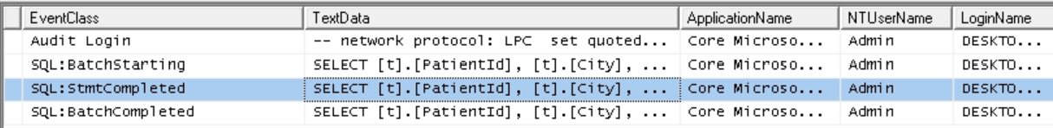

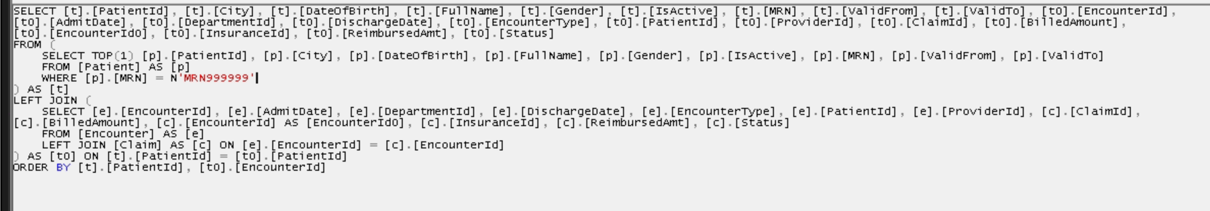

STEP 6 - RUN OPTION 4
Choose:
- Eager Loading Demo

Expected Output
EAGER LOADING DEMO
Patient Name : Rahul Verma
Encounters Loaded : 500
Claims Loaded : 500

PERFORMANCE SUMMARY
Patient Queries : 0
Encounter Queries : 0
Claim Queries : 0
Single Eager Loaded Query : 1
Elapsed Time : 150 ms
Actual values will vary by machine.

Metric | Module 2 | Module 3
Patient Queries | 1 | 0
Encounter Queries | 1 | 0
Claim Queries | 500 | 0
Total Queries | 502 | 1
Elapsed Time | 4000+ ms | 150-300 ms

Old Query (With Loop)
// Load all encounters for the patient
var encounters =
db.Encounters
.Where(e => e.PatientId == patient.PatientId)
.ToList();

int totalClaims = 0;

// For every encounter, execute another SQL query
foreach (var encounter in encounters)
{
var claims =
db.Claims
.Where(c =>
c.EncounterId ==
encounter.EncounterId)
.ToList();

totalClaims += claims.Count;
}

Query 1 -> Load Patient
Query 2 -> Load Encounters
Query 3 -> Load Claims for Encounter 1
Query 4 -> Load Claims for Encounter 2
Query 5 -> Load Claims for Encounter 3

After (Module 3 - Eager Loading)
// Load Patient, Encounters and Claims together
// in a single database query

var patient =
db.Patients

// Load related Encounters
.Include(p => p.Encounters)

// For each Encounter, also load Claims
.ThenInclude(e => e.Claims)

// Retrieve Rahul Verma
.FirstOrDefault(p => p.Mrn == "MRN999999");

Query 502 -> Load Claims for Encounter 500

WHY INCLUDE() WORKS
Include() tells EF Core:
"When loading the Patient, also load related Encounters."

ThenInclude() tells EF Core:
"When loading Encounters, also load their Claims."

Instead of repeatedly asking SQL Server for data, EF Core retrieves everything together and builds the object graph in memory.

BUSINESS IMPACT
- Nurses access patient records faster.
- Doctors spend less time waiting for screens.
- Database workload decreases.
- The application becomes scalable as patient history grows.
- This is one of the highest-impact performance improvements available in EF Core because only a few lines of code were changed while eliminating hundreds of unnecessary database calls.

MODULE 4 – EXPLICIT LOADING IN EF CORE

Why This Matters
In Module 3, we solved the N+1 Query Problem using Eager Loading with Include() and ThenInclude(). The Patient, Encounters, and Claims were loaded together using a single SQL query. This significantly reduced database round-trips and improved performance.

However, Eager Loading is not always the best choice.
Sometimes users do not need all related information. Loading unnecessary data increases memory usage, transfers more data across the network, and may impact performance when dealing with large object graphs.

For example, the Revenue Team investigating a billing issue may only need:
- Patient Information
- Encounter History

They do not need:
- Claims
- Diagnoses
- Procedures
- Insurance Details

Loading everything would be wasteful.
This is where Explicit Loading becomes useful. Explicit Loading allows developers to load related data only when required. EF Core initially retrieves the main entity and then loads specific related data later through a separate request.

Business Problem
CareBridge Hospital's Revenue Recovery Team is reviewing patient billing records.
The team first wants to see basic patient information. Only if the user chooses to investigate further should encounter history be loaded.

Loading all related information immediately would waste resources because most users never drill into the details.

The development team decides to load encounters only when required.

Expected Business Outcome
We will learn that:
- Eager Loading is useful when all related data is needed.
- Explicit Loading is useful when only some related data is needed.
- Developers should choose the loading strategy based on business requirements.

The key lesson is:
Eager Loading = Load everything now.
Explicit Loading = Load related data later when needed.

Program.cs

using System.Diagnostics;
using Microsoft.EntityFrameworkCore;
using CareBridge.PerformanceLab.Models;
while (true)
{
Console.Clear();
Console.WriteLine("=================================");
Console.WriteLine(" CAREBRIDGE PERFORMANCE LAB");
Console.WriteLine("=================================");
Console.WriteLine();

Console.WriteLine("1. View Patient");
Console.WriteLine("2. View Patient Encounters");
Console.WriteLine("3. Simulate N+1 Problem");
Console.WriteLine("4. Eager Loading Demo");
Console.WriteLine("5. Explicit Loading Demo");
Console.WriteLine("6. Exit");

Console.WriteLine();
Console.Write("Choose Option: ");

string? choice = Console.ReadLine();

switch (choice)
{
case "1":
ShowPatient();
break;

case "2":
ShowEncounters();
break;

case "3":
SimulateNPlusOne();
break;

case "4":
EagerLoadingDemo();
break;

case "5":
ExplicitLoadingDemo();
break;

case "6":
return;

default:
Console.WriteLine("Invalid Option");
break;
}

Console.WriteLine();
Console.WriteLine("Press any key to continue...");
Console.ReadKey();
}
static void ShowPatient()
{
using var db = new CareBridgeContext();
var patient =
db.Patients
.FirstOrDefault(p => p.Mrn == "MRN999999");

if (patient == null)
{
Console.WriteLine("Patient not found.");
return;
}

Console.WriteLine();
Console.WriteLine("PATIENT DETAILS");
Console.WriteLine("----------------------------");

Console.WriteLine($"Patient Id : {patient.PatientId}");
Console.WriteLine($"MRN : {patient.Mrn}");
Console.WriteLine($"Name : {patient.FullName}");
Console.WriteLine($"City : {patient.City}");
Console.WriteLine($"Active : {patient.IsActive}");
}
static void ShowEncounters()
{
using var db = new CareBridgeContext();
var patient =
db.Patients
.FirstOrDefault(p => p.Mrn == "MRN999999");

if (patient == null)
{
Console.WriteLine("Patient not found.");
return;
}

var encounters =
db.Encounters
.Where(e => e.PatientId == patient.PatientId)
.ToList();

Console.WriteLine();
Console.WriteLine("PATIENT ENCOUNTERS");
Console.WriteLine("----------------------------");

Console.WriteLine($"Patient Name : {patient.FullName}");
Console.WriteLine($"Encounter Count : {encounters.Count}");
}
static void SimulateNPlusOne()
{
using var db = new CareBridgeContext();
Console.WriteLine();
Console.WriteLine("SIMULATING N+1 QUERY PROBLEM");
Console.WriteLine("----------------------------");

var patient =
db.Patients
.FirstOrDefault(p => p.Mrn == "MRN999999");

if (patient == null)
{
Console.WriteLine("Patient not found.");
return;
}

Stopwatch stopwatch = Stopwatch.StartNew();

var encounters =
db.Encounters
.Where(e => e.PatientId == patient.PatientId)
.ToList();

int totalClaims = 0;

foreach (var encounter in encounters)
{
var claims =
db.Claims
.Where(c =>
c.EncounterId ==
encounter.EncounterId)
.ToList();

totalClaims += claims.Count;
}

stopwatch.Stop();

Console.WriteLine();
Console.WriteLine($"Patient Name : {patient.FullName}");
Console.WriteLine($"Encounters Loaded : {encounters.Count}");
Console.WriteLine($"Claims Loaded : {totalClaims}");

Console.WriteLine();
Console.WriteLine("PERFORMANCE SUMMARY");
Console.WriteLine("----------------------------");

Console.WriteLine("Patient Queries : 1");
Console.WriteLine("Encounter Queries : 1");
Console.WriteLine($"Claim Queries : {encounters.Count}");

Console.WriteLine();

Console.WriteLine(
$"Approx Total Queries : {encounters.Count + 2}");

Console.WriteLine(
$"Elapsed Time : {stopwatch.ElapsedMilliseconds} ms");
}
static void EagerLoadingDemo()
{
using var db = new CareBridgeContext();
Console.WriteLine();
Console.WriteLine("EAGER LOADING DEMO");
Console.WriteLine("----------------------------");

Stopwatch stopwatch = Stopwatch.StartNew();

var patient =
db.Patients
.Include(p => p.Encounters)
.ThenInclude(e => e.Claims)
.FirstOrDefault(p => p.Mrn == "MRN999999");

stopwatch.Stop();

if (patient == null)
{
Console.WriteLine("Patient not found.");
return;
}

int encounterCount =
patient.Encounters.Count;

int claimCount =
patient.Encounters
.SelectMany(e => e.Claims)
.Count();

Console.WriteLine();
Console.WriteLine($"Patient Name : {patient.FullName}");
Console.WriteLine($"Encounters Loaded : {encounterCount}");
Console.WriteLine($"Claims Loaded : {claimCount}");

Console.WriteLine();

Console.WriteLine("PERFORMANCE SUMMARY");
Console.WriteLine("----------------------------");

Console.WriteLine("Patient Queries : 0");
Console.WriteLine("Encounter Queries : 0");
Console.WriteLine("Claim Queries : 0");

Console.WriteLine();
Console.WriteLine("Single Include Query : 1");

Console.WriteLine();

Console.WriteLine(
$"Elapsed Time : {stopwatch.ElapsedMilliseconds} ms");
}
static void ExplicitLoadingDemo()
{
using var db = new CareBridgeContext();
Console.WriteLine();
Console.WriteLine("EXPLICIT LOADING DEMO");
Console.WriteLine("----------------------------");

Stopwatch stopwatch = Stopwatch.StartNew();

// Query 1
// Load only Patient
var patient =
db.Patients
.FirstOrDefault(p => p.Mrn == "MRN999999");

if (patient == null)
{
Console.WriteLine("Patient not found.");
return;
}

Console.WriteLine();
Console.WriteLine("Step 1");
Console.WriteLine("Patient Loaded");

Console.WriteLine($"Patient Name : {patient.FullName}");

Console.WriteLine();

Console.WriteLine("Step 2");
Console.WriteLine("Loading Encounters Explicitly");

// Query 2
// Load Encounters only when required
db.Entry(patient)
.Collection(p => p.Encounters)
.Load();

stopwatch.Stop();

Console.WriteLine();

Console.WriteLine(
$"Encounters Loaded : {patient.Encounters.Count}");

Console.WriteLine();

Console.WriteLine("PERFORMANCE SUMMARY");
Console.WriteLine("----------------------------");

Console.WriteLine("Patient Query : 1");
Console.WriteLine("Encounter Query : 1");
Console.WriteLine("Claim Queries : 0");

Console.WriteLine();

Console.WriteLine("Total Queries : 2");

Console.WriteLine();

Console.WriteLine(
$"Elapsed Time : {stopwatch.ElapsedMilliseconds} ms");

Console.WriteLine();

Console.WriteLine("Check SQL Profiler");

Console.WriteLine(
"You should see only 2 SQL queries.");

Console.WriteLine(
"Patient Query + Encounter Query");
}

STEP 5 – CLEAR SQL PROFILER
Before running the demo:
Stop the existing trace.
Create a new trace.
Select only:
TSQL
✓ SQL:BatchStarting
✓ SQL:BatchCompleted
Stored Procedures
✓ RPC:Completed
Click Run.
The profiler window should now be empty.

STEP 6 – RUN OPTION 5
Choose:
- Explicit Loading Demo

Expected Output
EXPLICIT LOADING DEMO
Step 1
Patient Loaded
Patient Name : Rahul Verma
Step 2
Loading Encounters Explicitly
Encounters Loaded : 500

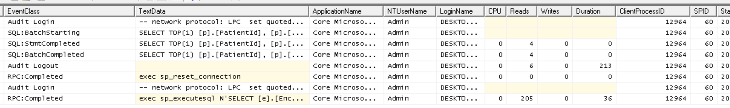

PERFORMANCE SUMMARY
Patient Query : 1
Encounter Query : 1
Claim Queries : 0
Total Queries : 2
Elapsed Time : 80 ms
Actual values will vary by machine.
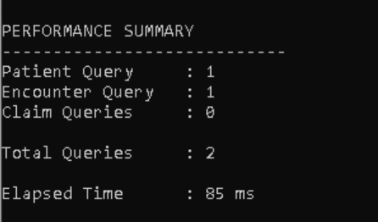

STEP 7 – OBSERVE SQL PROFILER
We should now switch to SQL Profiler.
They should see only:
Query 1 SELECT Patient
and
Query 2 SELECT Encounter
Nothing else.

There should be:
No Claim Queries
No Diagnosis Queries
No Procedure Queries

This proves EF Core only loaded the data that was requested.

COMPARE ALL LOADING STRATEGIES
Module 2
N+1 Query Problem
Patient Query : 1
Encounter Query : 1
Claim Queries : 500
Total Queries : 502

Module 3
Eager Loading
Single Include Query : 1
Total Queries : 1

Module 4
Explicit Loading
Patient Query : 1
Encounter Query : 1
Claim Queries : 0
Total Queries : 2

Module 3 – Eager Loading
// Load Patient, Encounters and Claims
// immediately in a single SQL query

var patient =
db.Patients

// Load all related Encounters
.Include(p => p.Encounters)

// For every Encounter,
// also load related Claims
.ThenInclude(e => e.Claims)

// Fetch Rahul Verma
.FirstOrDefault(p => p.Mrn == "MRN999999");

Module 4 – Explicit Loading
// STEP 1
// Load only Patient

var patient =
db.Patients
.FirstOrDefault(p => p.Mrn == "MRN999999");

// STEP 2
// Later, when user requests Encounter data,
// load Encounters explicitly

db.Entry(patient)

// Access Encounter collection
.Collection(p => p.Encounters)

// Execute separate SQL query
.Load();

Key Learning
- There is no single loading strategy that is always correct.
- The best strategy depends on the business requirement.
- Understanding when to use Eager Loading and when to use Explicit Loading is a critical skill for enterprise EF Core development.
MODULE 5 – IMPROVING READ-ONLY PERFORMANCE WITH AsNoTracking()

Why This Matters
In the previous modules, we focused on reducing unnecessary SQL queries. We learned how the N+1 Query Problem can generate hundreds of database calls and how Eager Loading can reduce those calls to a single optimized query.

However, database queries are only one part of application performance.

Whenever EF Core loads data from SQL Server, it automatically tracks every entity in memory. This process is called Change Tracking.

Tracking allows EF Core to detect modifications and automatically generate INSERT, UPDATE, and DELETE statements when SaveChanges() is called.

While this behavior is useful for data entry screens, it provides no benefit for read-only screens such as reports and dashboards.

Examples include:
- Revenue Dashboard
- Claims Analytics
- Executive Reporting
- Operational KPIs

These screens display information but never update records.
In these situations, EF Core spends memory and CPU resources tracking entities that will never be modified.

AsNoTracking() tells EF Core:
"Load the data, but do not track it."

This reduces memory consumption and improves performance for read-only workloads.

Business Problem
Every morning, CareBridge executives open the Revenue Dashboard to review claims activity.
The dashboard displays:
- Total Claims
- Paid Claims
- Denied Claims
- Revenue At Risk

The screen is completely read-only. Nobody updates claims from this dashboard.
However, EF Core still tracks every claim object loaded into memory.

As the system grows to thousands of claims, tracking creates unnecessary overhead.

The development team decides to disable tracking for this screen.
Expected Business Outcome
We will learn:
- Why EF Core tracks entities
- Why tracking is unnecessary for reports
- How AsNoTracking() improves performance
- How to measure tracked entities
- When AsNoTracking() should be used

Important Rule
Use tracking when data will be modified.
Use AsNoTracking() when data is only being displayed.

using System.Diagnostics;
using Microsoft.EntityFrameworkCore;
using CareBridge.PerformanceLab.Models;

while (true)
{
Console.Clear();

Console.WriteLine("=================================");
Console.WriteLine(" CAREBRIDGE PERFORMANCE LAB");
Console.WriteLine("=================================");
Console.WriteLine();

Console.WriteLine("1. View Patient");
Console.WriteLine("2. View Patient Encounters");
Console.WriteLine("3. Simulate N+1 Problem");
Console.WriteLine("4. Eager Loading Demo");
Console.WriteLine("5. Explicit Loading Demo");
Console.WriteLine("6. AsNoTracking Demo");
Console.WriteLine("7. Exit");

Console.WriteLine();
Console.Write("Choose Option: ");

string? choice = Console.ReadLine();

switch (choice)
{
case "1":
ShowPatient();
break;

case "2":
ShowEncounters();
break;

case "3":
SimulateNPlusOne();
break;

case "4":
EagerLoadingDemo();
break;

case "5":
ExplicitLoadingDemo();
break;

case "6":
AsNoTrackingDemo();
break;

case "7":
return;

default:
Console.WriteLine("Invalid Option");
break;
}

Console.WriteLine();
Console.WriteLine("Press any key to continue...");
Console.ReadKey();
}

static void ShowPatient()
{
using var db = new CareBridgeContext();

var patient =
db.Patients
.FirstOrDefault(p => p.Mrn == "MRN999999");

if (patient == null)
{
Console.WriteLine("Patient not found.");
return;
}

Console.WriteLine();
Console.WriteLine("PATIENT DETAILS");
Console.WriteLine("----------------------------");

Console.WriteLine($"Patient Id : {patient.PatientId}");
Console.WriteLine($"MRN : {patient.Mrn}");
Console.WriteLine($"Name : {patient.FullName}");
Console.WriteLine($"City : {patient.City}");
Console.WriteLine($"Active : {patient.IsActive}");
}

static void ShowEncounters()
{
using var db = new CareBridgeContext();

var patient =
db.Patients
.FirstOrDefault(p => p.Mrn == "MRN999999");

if (patient == null)
{
Console.WriteLine("Patient not found.");
return;
}

var encounters =
db.Encounters
.Where(e => e.PatientId == patient.PatientId)
.ToList();

Console.WriteLine();
Console.WriteLine("PATIENT ENCOUNTERS");
Console.WriteLine("----------------------------");

Console.WriteLine($"Patient Name : {patient.FullName}");
Console.WriteLine($"Encounter Count : {encounters.Count}");
}

static void SimulateNPlusOne()
{
using var db = new CareBridgeContext();

Console.WriteLine();
Console.WriteLine("SIMULATING N+1 QUERY PROBLEM");
Console.WriteLine("----------------------------");

var patient =
db.Patients
.FirstOrDefault(p => p.Mrn == "MRN999999");

if (patient == null)
{
Console.WriteLine("Patient not found.");
return;
}

Stopwatch stopwatch = Stopwatch.StartNew();

var encounters =
db.Encounters
.Where(e => e.PatientId == patient.PatientId)
.ToList();

int totalClaims = 0;

foreach (var encounter in encounters)
{
var claims =
db.Claims
.Where(c => c.EncounterId == encounter.EncounterId)
.ToList();

totalClaims += claims.Count;
}

stopwatch.Stop();

Console.WriteLine();
Console.WriteLine($"Patient Name : {patient.FullName}");
Console.WriteLine($"Encounters Loaded : {encounters.Count}");
Console.WriteLine($"Claims Loaded : {totalClaims}");

Console.WriteLine();
Console.WriteLine("PERFORMANCE SUMMARY");
Console.WriteLine("----------------------------");

Console.WriteLine("Patient Queries : 1");
Console.WriteLine("Encounter Queries : 1");
Console.WriteLine($"Claim Queries : {encounters.Count}");

Console.WriteLine();

Console.WriteLine(
$"Approx Total Queries : {encounters.Count + 2}");

Console.WriteLine(
$"Elapsed Time : {stopwatch.ElapsedMilliseconds} ms");
}

static void EagerLoadingDemo()
{
using var db = new CareBridgeContext();

Console.WriteLine();
Console.WriteLine("EAGER LOADING DEMO");
Console.WriteLine("----------------------------");

Stopwatch stopwatch = Stopwatch.StartNew();

var patient =
db.Patients
.Include(p => p.Encounters)
.ThenInclude(e => e.Claims)
.FirstOrDefault(p => p.Mrn == "MRN999999");

stopwatch.Stop();

if (patient == null)
{
Console.WriteLine("Patient not found.");
return;
}

int encounterCount =
patient.Encounters.Count;

int claimCount =
patient.Encounters
.SelectMany(e => e.Claims)
.Count();

Console.WriteLine();
Console.WriteLine($"Patient Name : {patient.FullName}");
Console.WriteLine($"Encounters Loaded : {encounterCount}");
Console.WriteLine($"Claims Loaded : {claimCount}");

Console.WriteLine();

Console.WriteLine("PERFORMANCE SUMMARY");
Console.WriteLine("----------------------------");

Console.WriteLine("Single Include Query : 1");

Console.WriteLine();

Console.WriteLine(
$"Elapsed Time : {stopwatch.ElapsedMilliseconds} ms");
}

static void ExplicitLoadingDemo()
{
using var db = new CareBridgeContext();

Console.WriteLine();
Console.WriteLine("EXPLICIT LOADING DEMO");
Console.WriteLine("----------------------------");

Stopwatch stopwatch = Stopwatch.StartNew();

var patient =
db.Patients
.FirstOrDefault(p => p.Mrn == "MRN999999");

if (patient == null)
{
Console.WriteLine("Patient not found.");
return;
}

db.Entry(patient)
.Collection(p => p.Encounters)
.Load();

stopwatch.Stop();

Console.WriteLine();
Console.WriteLine($"Patient Name : {patient.FullName}");
Console.WriteLine($"Encounters Loaded : {patient.Encounters.Count}");

Console.WriteLine();

Console.WriteLine("PERFORMANCE SUMMARY");
Console.WriteLine("----------------------------");

Console.WriteLine("Patient Query : 1");
Console.WriteLine("Encounter Query : 1");
Console.WriteLine("Total Queries : 2");

Console.WriteLine();

Console.WriteLine(
$"Elapsed Time : {stopwatch.ElapsedMilliseconds} ms");
}

static void AsNoTrackingDemo()
{
Console.WriteLine();
Console.WriteLine("ASNOTRACKING PERFORMANCE DEMO");
Console.WriteLine("------------------------------------------------");

long normalMemoryConsumed = 0;
long noTrackingMemoryConsumed = 0;

//
// Cleanup before measurement
//
GC.Collect();
GC.WaitForPendingFinalizers();
GC.Collect();

//
// SCENARIO 1
// Normal Query
//
using (var db = new CareBridgeContext())
{
Console.WriteLine();
Console.WriteLine("SCENARIO 1 - NORMAL QUERY");
Console.WriteLine("------------------------------------------------");

long memoryBefore =
GC.GetTotalMemory(true);

Stopwatch stopwatch =
Stopwatch.StartNew();

var claims =
db.Claims
.ToList();

stopwatch.Stop();

long memoryAfter =
GC.GetTotalMemory(false);

normalMemoryConsumed =
memoryAfter - memoryBefore;

Console.WriteLine();

Console.WriteLine(
$"Claims Loaded : {claims.Count}");

Console.WriteLine(
$"Tracked Entities : {db.ChangeTracker.Entries().Count()}");

Console.WriteLine(
$"Elapsed Time : {stopwatch.ElapsedMilliseconds} ms");

Console.WriteLine(
$"Memory Consumed : {normalMemoryConsumed:N0} bytes");
}

Console.WriteLine();
Console.WriteLine();

//
// Cleanup before second test
//
GC.Collect();
GC.WaitForPendingFinalizers();
GC.Collect();

//
// SCENARIO 2
// AsNoTracking
//
using (var db = new CareBridgeContext())
{
Console.WriteLine();
Console.WriteLine("SCENARIO 2 - ASNOTRACKING()");
Console.WriteLine("------------------------------------------------");

long memoryBefore =
GC.GetTotalMemory(true);

Stopwatch stopwatch =
Stopwatch.StartNew();

var claims =
db.Claims

// Disable Change Tracking
.AsNoTracking()

.ToList();

stopwatch.Stop();

long memoryAfter =
GC.GetTotalMemory(false);

noTrackingMemoryConsumed =
memoryAfter - memoryBefore;

Console.WriteLine();

Console.WriteLine(
$"Claims Loaded : {claims.Count}");

Console.WriteLine(
$"Tracked Entities : {db.ChangeTracker.Entries().Count()}");

Console.WriteLine(
$"Elapsed Time : {stopwatch.ElapsedMilliseconds} ms");

Console.WriteLine(
$"Memory Consumed : {noTrackingMemoryConsumed:N0} bytes");
}

//
// Final Comparison
//
double memorySavingsPercent =
((double)(normalMemoryConsumed - noTrackingMemoryConsumed)
/ normalMemoryConsumed) * 100;

Console.WriteLine();
Console.WriteLine("PERFORMANCE COMPARISON");
Console.WriteLine("------------------------------------------------");

Console.WriteLine(
$"Normal Memory Usage : {normalMemoryConsumed:N0} bytes");

Console.WriteLine(
$"AsNoTracking Memory Usage : {noTrackingMemoryConsumed:N0} bytes");

Console.WriteLine(
$"Memory Saved : {(normalMemoryConsumed - noTrackingMemoryConsumed):N0} bytes");

Console.WriteLine(
$"Memory Saved (%) : {memorySavingsPercent:F2}%");

Console.WriteLine();

Console.WriteLine("Key Learning");
Console.WriteLine("------------------------------------------------");

Console.WriteLine(
"Same SQL Query");

Console.WriteLine(
"Same Data Returned");

Console.WriteLine(
"Less EF Core Tracking");

Console.WriteLine(
"Lower Memory Usage");
}

Step 1 - Run Option 6

SCENARIO 1
Claims Loaded
Tracked Entities
Elapsed Time

Example:
Claims Loaded : 22000
Tracked Entities : 22000
Elapsed Time : 265 ms

Run AsNoTracking()
Students observe:
Claims Loaded : 22000
Tracked Entities : 0
Elapsed Time : 188 ms

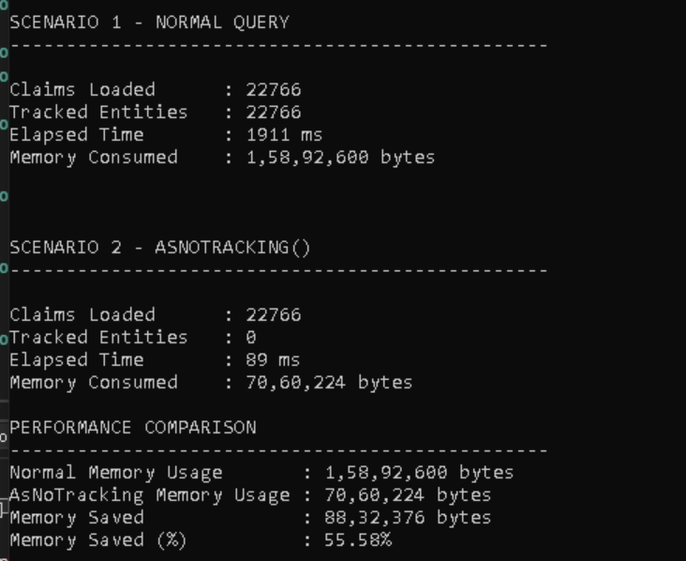

Before - Normal EF Core Query
// Load all Claims from SQL Server
var claims =
db.Claims
.ToList();

// EF Core loads the Claims
// AND starts tracking every Claim object

Console.WriteLine(
$"Tracked Entities : {db.ChangeTracker.Entries().Count()}");

What EF Core Does
Load 22000 Claims
↓
Track 22000 Claims
↓
Monitor Changes
↓
Consume Additional Memory
Typical Output:
Claims Loaded : 22000
Tracked Entities : 22000

After - AsNoTracking()

// Load all Claims from SQL Server

var claims =
db.Claims

// Tell EF Core:
// Load the data
// BUT do not track it
.AsNoTracking()

.ToList();

// Verify tracked entities

Console.WriteLine(
$"Tracked Entities : {db.ChangeTracker.Entries().Count()}");

What EF Core Does
Load 22000 Claims
↓
Do NOT Track Claims
↓
Do NOT Monitor Changes
↓
Less Memory Usage
Typical Output:
Claims Loaded : 22000
Tracked Entities : 0

Then why is it faster?
Answer: EF Core stopped monitoring 22000 objects.

Discussion
Problem | Solution | Result
N+1 Queries | Include() | 502 → 1 Query
Loading Too Much | Explicit Loading | Load Only Required Data
Tracking Too Many Entities | AsNoTracking() | 22000 → 0 Tracked

